

DESIGNING A FRAMEWORK WITH A NOVEL FEATURE SELECTION METHOD FOR PREDICTING MORTALITY IN CARDIAC PATIENTS
This Thesis is submitted to the Department of Computer Science as partial fulfillment of Master of Science in Data Science degree

by

Ibrahim Abdurrab

Supervised by

Dr. Tariq Mahmood
Professor
Department of Computer Science
School of Mathematics and Computer Science (SMCS)
Institute of Business Administration (IBA), Karachi

Spring Semester 2022
Institute of Business Administration (IBA), Karachi, Pakistan


DESIGNING A FRAMEWORK WITH A NOVEL FEATURE SELECTION METHOD FOR PREDICTING MORTALITY IN CARDIAC PATIENTS
This Thesis is submitted to the Department of Computer Science as partial fulfillment of Master of Science in Data Science degree

by

Ibrahim Abdurrab
(Student Number: 23385)

Committee:

Dr. Tariq Mahmood
Supervisor
Institute of Business Administration (IBA), Karachi

Dr. Tahir Syed
Examiner - I
Institute of Business Administration (IBA), Karachi

Dr. …..
Examiner - II
Institute of Business Administration (IBA), Karachi

Dr. Shakeel Ahmed Khoja
Dean
School of Mathematics & Computer Science

Spring Semester 2022
Institute of Business Administration (IBA), Karachi, Pakistan

Copyright: 2022, Ibrahim Abdurrab
All Rights Reserved

Dedication
This work is hereby dedicated to my beloved family and honorable teachers.

Acknowledgement
I greatly appreciate the guidance provided by my supervisor Dr. Tariq Mahmood who encouraged me to take this challenging task and helped me throughout the course of this research. I also gratefully acknowledge the support of my colleagues at Tabba Heart Institute who provided the required data and assisted me in making this research a reality.

Table of Contents
Abstract 10
Chapter 1 1
Introduction 1
Chapter 2 5
Background 5
2.1 Feature Selection 7
2.1.1 PCA 7
2.1.2 Lasso Regression 7
2.1.3 Ridge Regression 8
2.1.4 Random Forest 8
2.1.5 XGBoost 8
2.2 Models 9
2.2.1 XGBoost 9
2.2.2 Logistic Regression 9
2.2.3 Random Forest 9
Chapter 3 11
Literature Review 11
3.1 Literature Compilation 11
3.2 Literature Explanation 14
3.3 Gap Analysis 19
Chapter 4 22
Methodology 22
4.1 Dataset 22
4.2 Feature Selection 23
4.3 Models 24
4.3.1 Bayesian Inference Model 24
4.3.2 Firth Logistic Regression Model 27
Chapter 5 28
Results & Discussion 28
Chapter 6 34
Conclusion 34
References 36

List of Tables
Table 1: Preliminary Analysis 10
Table 2: Chi-sq & P-values 22
Table 3: FS & F1 Score 23
Table 4: Ensemble Feature List 24
Table 5: Coefficients 33

List of Figures
Figure 1: Research Article Per Source 12
Figure 2: Article Per Research Category 13
Figure 3: Research Article Per Year 13
Figure 4: Trace Plot (Ensemble FS) 28
Figure 5: ROC vs Threshold (MCMC) 28
Figure 6: Recall vs Threshold (MCMC) 29
Figure 7: Precision vs Threshold (MCMC) 30
Figure 8: ROC (Baseline) 31
Figure 9: Trace Plot (Baseline) 31
Figure 10: Precision vs Threshold (Firth) 32
Figure 11: Recall vs Threshold (Firth) 32
Figure 12: ROC vs Threshold (Firth) 33

Abstract
The aim of this study is to generate a universal predictive framework for mortality prediction of cardiac patients based on pre-operative variables. The research also aims to find the factors that lead to operative mortality in cardiac patients. Once these factors are identified, they would serve as base line variables for any such predictive model. To generate a universal comprehensive framework, a novel feature selection method will be introduced which will incorporate professional bias into the rankings. This will ensure that the process of feature selection filters the predictors that are diagnostically correct. The use of Machine Learning (ML) along with Bayesian Inference Methods and Firth Logistic will be employed to check their robustness on imbalanced classification task.

Keywords: Pre-Operative, Machine Learning, Bayesian Methods

Chapter 1

Introduction
Since decades the art of predictive modelling has been used by professionals around the world to unveil the contingencies and irregularities that were often persistent in the underlying data. As the field of computer science matured with technological advancements, the art of prediction expanded to every field known to mankind. However, the degree to which each field makes use of predictive modelling varies greatly. For instance, environmentalists cannot work without statistical models to forecast the minute changes in earth’s global temperature. Technological firms almost always use customer data and predictive analytics tools to forecast the cohort behavior. Similarly, airlines use air traffic and weather data to draw carrier routes. All the stated fields rely more heavily on different forecasting techniques to solve their daily pertaining problems. However, one field of sciences that is often overlooked in terms of its data and predictive prowess is medical sciences. The inclusion and use of data in healthcare is not nascent. Various prescriptive analytics techniques used by clinical professionals are as old as the field itself. Along with that some old and new risk stratification models and newer machine and deep learning techniques have also found their way into current medical literature. With all these cursory developments in the domain, it still lacks the sound and focused research into the framework that derives from these studies, especially when it comes to predicting in-hospital mortality of cardiac patients. This is one of the primary motivations behind this research.
Chronic heart diseases and its associated risks are still one of the primary reasons behind mortality and morbidity (Savarese and Lund 2017). With advancements in the quality of healthcare services the median global age has been increasing yearly. In 2015, the average global age was only 29.6 years, which increased to 38.2 years in 2020. The trend signifies that the quality of medical services provided to the population has increased multifold. Clinicians are better equipped to combat health emergencies that were deemed impossible a few years back. As great as it is, it certainly gives rise to other dangers. As most of the global population is older than ~40 years, they are more susceptible to chronic heart diseases, because old age is a distinct predictor of in-hospital mortality (Rodgers, et al. 2019). This trend is only going to be more apparent with the advancing global age. With advancements and leaps in the domain of medicine, healthcare professionals have led several focused research to propose methods and materials to overcome the appalling danger that comes with cardiac diseases. Various enzyme inhibitors, beta-blockers, angiotensin-receptor blockers have improved the overall survival rate of such patients. Yet attributing to the chronic nature of cardiac diseases, recurring hospitalization and readmission to ICU poses a great economical issue to medical centers. Multiple readmissions of a high-risk patient put a great strain on one’s health and the limited resources available at clinician’s disposal (Lesyuk, Kriza and Kolominsky-Rabas 2018). To stratify high risk patients and the morbid outcomes that might occur, health professionals have different treatment strategies that are resultant of risk prediction models. Various risk-prediction models have been created to bio statistically predict the risk associated with cardiac diseases. Most of these models are created by linear weighted sum of various clinical variables that the researcher deems critical. More high-risk factors that can lead to in-hospital mortality in a cardiac patient are given a relatively high score than the low risk factors. These kinds of models, simple as they seem, work well on a limited scale and are particular to the data on which they are created. Clinicians are often hesitant and even wary to use this kind of risk stratification model, firstly due to their inert bias, introduced by the cohort on which they are created. This raises serious questions about the model’s reliability and reusability. Secondly, due to the vast number of these kinds of models in making, choosing the one that works for a particular patient is never an easy task. This paradox of choice renders healthcare professionals without any model. Instead of choosing one from many, they prefer none. In addition, the complexity of some methodologies further sways them away from using these methods in daily practice. Another reason for clinicians’ reluctance on using risk-stratification models stems from the fact that each methodology uses different variable selection methods. Healthcare data is mostly high dimensional which makes it ominous to create valid models with good accuracy. To transform the data into a representative low dimension, researchers often employ the use of multiple feature selection techniques. The data in the lower dimension is much easier to train a model on without any significant accuracy loss. The parameters are selected in such a way that the variance of the original data is not disturbed. In the field of medical sciences, the parameters that are diagnostically viable and help to stratify high-risk patients are called ‘biomarkers’. In other words, the parameters that are fished out after using feature selection techniques are regarded as biomarkers. These parameters are known to explain the original data with considerable variance. Furthermore, these parameters are said to represent the model at hand in the best possible way. The selection of biomarkers varies greatly based on the nature of the cohort, problem statement of the study, and the researcher’s background. Often, a model trained on one set of biomarkers is not acceptable to another clinician because of the difference of opinion that exists among severity of high-risk factors. Due to this absence of consensus, researchers are mostly inclined towards using standalone feature selection techniques to reduce the dimension of the original data. This procedure, however, is effective and easy, raises a concern over validity of the selected features as the selection process does not consider the professional opinion of the related personnel. This could result in some features getting precedence over those predictors that are more clinically viable and diagnostically essential to predict the outcome of interest. (Rahimi, et al. 2014) further endorses these reservations that sits with healthcare professionals when it comes to using any risk stratification model. According to their study, various models are in fact clinically viable and even beneficial if used correctly. However, the variations that exist within the model along with their statistical differences (number of parameters, data etc.) and feature section methods makes it impossible to recommend one. Hence feature selection and later model selection is a critical task which must have some level of professional insight incorporated into it. Standalone feature selection and model creation techniques do not provide such capabilities of professional insight. This gap in literature acts as another motivation for this study.
The aim of the research is to make a consolidated framework comprising of a novel approach to feature selection along with creation of a model that could help clinicians to predict mortality of cardiac patients based on biomarkers. This kind of early prediction is especially important because postoperative cardiac complications pose a great threat to the life of a patient. If an idea of the grave outcome of the surgery is somehow known beforehand, an alternative and safer procedure can be recommended to the patient under observation, potentially saving their life. In addition to that, the financial resources of the patient and logistic and instrumental resources of the hospital can be saved by predicting postoperative (after operation) complications. Since ages healthcare professionals have tried to use the patient data to devise models, scoring charts and surgical indexes to keep track of risk factors and their probable outcome on the patients. The practice of making scoring models based on preoperative (before operation) risk factors has been the norm for health care professionals. These scoring models work well for a limited population and are highly constrained by the geographical area. Furthermore, these biostatistical models assume linear dependence of the target variable with the exogenous variables which is not true. Especially in a real-world phenomenon where any kind of interference can result in an unexpected outcome. The practice (of making scoring models) is so common that the domain is stricken with several scoring models from which none is universal. For example, EuroScore is used to predict the preoperative mortality risk of cardiac patients, which is limited to the European countries. AusScore is yet another scoring model which is built and is local to Australian population. In addition to that absence of professional insight into the process of feature selection is often overlooked in creating these predictive models. These constraints limit the use of these models to effectively predict the mortality of a patient suffering from a cardiac disease. The framework proposed in this study would start with a comprehensive qualitative survey used to collect medical experts’ opinions about the diagnostic validity of several parameters. Later these opinions will be translated into weighted scores assigned to each of the parameters of the original data. These weights/scores along with multiple feature selection techniques will be used in conjunction to introduce clinical opinion of healthcare professionals in the process of feature selection which is not seen in the relevant literature. With this tweak it is assumed that diagnostically relevant features would be made part of model training step which could greatly enhance the accuracy of mortality predicting model. The study would further dive into machine learning and deep learning paradigm shift in healthcare industry that leads to different methodologies, models and metrics used in mortality prediction of cardiac patients. Given the nature of the dataset, Bayesian Inference methods and Firth Logistic Regression models will be investigated. Furthermore, this research would serve as a baseline study that provides a comprehensive knowledge and framework about old and tested methods along with new and novel models used in any geographical setting to predict in-hospital mortality. Finally, the research would make use of data compiled by tertiary care, referral heart institute in Karachi, Pakistan (named as Tabba Heart Institute) and will be the first of its kind for a developing state.

Chapter 2

Background
The objective of the study is to propose a framework that incorporates a novel, professionally weighted, ensemble feature selection technique along with multiple machine and deep learning models to predict pre-operative mortality of cardiac patients. With the data provided by the partner institute, a preliminary analysis of the data was done to substantiate the stance taken in this study. The following sections provide information regarding the background knowledge of the techniques used along with their results.
It is widely believed that feature selection or data reduction techniques results in good accuracy when the data is high dimensional – as is the case in this study where the acquired data has more than 140 different variables. Feature selection, attribute selection, or variable selection is a process of extracting those features from the original dataset that are uncorrelated and influences the target variable the most. The terms feature selection and dimensionality reduction are often used interchangeably. The practice though innocuous does not erase the need to describe the latter. Dimensionality reduction refers to those data reduction techniques that transform the original dataset variables into different set of lower dimensional features. Once the variables are transformed to a lower axis, they are unrecognizable as the original features. They become a linear combination of original variables generated via different mathematical functions performed on them. Most common dimensionality reduction techniques such as Principal Component Analysis and Linear Discriminant Analysis, works based on calculating eigen values and their corresponding eigen vectors of a covariance (or in some cases inverse covariance) matrices of the original feature set. These kinds of data reduction techniques are especially useful when mere accuracy of the final model is under consideration without paying any heed to the predictors that lead to it. Because once the transformation is done and the model is generated, one cannot go back and review the original features of the dataset that made up the model. Simply put, data reduction techniques transform original features of a dataset into unrecognizable, latent variables that are a linear combination of the original and retain most of the dataset variance. Feature selection on the other hand, works in such a way that it reduces the original number of predictors to a subset of relevant features. There are three broad categories of feature selection methods namely, filter methods, wrapper methods and embedded methods.
Filter methods are conceptually and computationally simpler than their counterparts. These types of feature selection techniques make use of statistical methods to quantify the relationship between each of the predictors and the target variable. The statistical method used for the filtration ranges from a simple Pearson Chi-Square test to a Dickey Fuller p-value Test. These kinds of feature selection techniques are mostly used to understand the theoretical foundations of the underlying data. It helps to understand the multicollinearity, variance, correlation, and complexity of each predictor of a dataset.
Wrapper methods or model-based feature selection techniques are a bit complex and computationally extensive. They work on the principle of recursive model creation and testing. Each model is created with a different set of parameters selected from the pool of original predictors. In this manner all possible feature combinations are tested and the best one (or averaged one) is selected as output. There are multiple algorithms via which this selection of parameters is performed. Step Forward Feature Selection – starts with evaluating one feature and assessing it against a defined metric after training it on a model. Then, recursively adds more features until no improvement in model accuracy occurs with addition of more variables. Step Backward Feature Selection – starts with evaluating the model on all features of the dataset. Then each feature is removed, and the model is assessed. This iterative process continues until no further improvement occurs. Exhaustive Feature Selection – the most computationally expensive method of feature selection. It repeatedly creates models at each iteration with a set of parameter s different from the previous one in such a way that all possible combinations of feature sets are evaluated. All wrapper-based feature selection techniques can be classified into these broad categories. These categories seemingly different have a common constituent – a model. Any classification or regression machine learning model (logistic regression, random forest, XGBoost, SVM etc.) can be incorporated into a wrapper-based feature selection technique with selection method either step forward, backward, or exhaustive.
Embedded methods of feature selection, as the name suggests, are a mixture of filter and wrapper methods. Embedded methods of feature selection, selects the features and creates the model in parallel, hence reducing the computation time. Wrapper and embedded methods are often confused together because both utilize feature selection to happen via learning of a machine learning model. This may appear to be the case; however, wrapper methods often consider less important predictors to be part of the evaluating feature set iteratively. Whereas embedded methods select and then trains the model at the same time. Random forests and other decision tree-based models are usually regarded as embedded methods because at each split of a tree, the model creation and feature selection occur simultaneously. However, these models can also be used in wrapper-based feature selection method as well. Hence, it largely depends upon the practitioner on how and which method of feature selection they use as per given problem.

2.1 Feature Selection
To create a novel feature selection technique as part of a consolidated framework, it is imperative to test the already existing feature selection techniques and a few machine learning models on the given data to ascertain whether these techniques work in addition to creating a baseline for further analysis. Model creation often follows the step of feature selection. The features fished out in the selection process are later used to train and test the model. A brief explanation of feature selection techniques along with the models used in preliminary analysis are given below:

2.1.1 PCA
Principal component analysis is one of the oldest and most widely used data reduction technique. The difference between feature selection and data reduction is the resultant variable. In feature selection, the outcome is a subset of original features whereas in data reduction the outcome is a transformed latent variable (principal component) different from the original dataset. PCA works by creating covariance matrix and using linear algebra to calculate corresponding eigen values and eigen vectors. These eigen vectors retain the variance of the original dataset effectively transforming a high dimensional data to a low dimensional axis.

2.1.2 Lasso Regression
Lest Absolute Shrinkage and Selection Operator or L1 regression is an embedded method of feature selection. It is a regularization technique that recursively penalizes highly correlated predictors by an amount equivalent to absolute value of the magnitude of the predictors such that features which are redundant are effectively discarded. Lasso helps to reduce overfitting by penalizing overly complex models by reducing or shrinking them to zero. The shrinkage or lambda is the parameter that controls the sparsity of the model. Larger values tend to create a simpler model with few parameters while smaller values lead to a more complex one.
$$\sum_{i=1}^{m}{{{(y}^{i}-x^{i}\hat{β})}^{2}+ λ\sum_{j=1}^{n}{\left|{\hat{β}}^{j}\right|}}$$

2.1.3 Ridge Regression
Ridge regression of L2 feature selection technique is a more sophisticated variant of L1 regularization. Instead of reducing coefficients of the predictors to zero, it reduces them to a marginal amount such that their fluctuating effect is diminished. It adds sum of squares of coefficients to the objective function as a penalty. Like Lasso regression, the value of lambda determines the complexity of the model. Higher values reduce the overfitting by reducing the high variance predictors (reducing them to a smaller value but not zero).
Smaller values of lambda retain the correlated features, hence creating a complex model.
$$\sum_{i=1}^{m}{{{(y}^{i}-x^{i}\hat{β})}^{2}+ λ\sum_{j=1}^{n}{{\left|{\hat{β}}^{j}\right|}^{2}}}$$

2.1.4 Random Forest
Random forest is an ensemble technique which is used to select features based on their relative importance. It ranks the features based on their influence on the target variable. This is done by creating individual ‘decision trees’ multiple times, in such a way that each split of an individual tree includes only those features that minimizes a particular loss metric. Usually, the metric of choice is Gini-Impurity (for classification datasets) and Mean Absolute Error (for regression datasets). The most important predictors for each decision tree are then ranked and averaged over all trained decision trees. The output is a consolidated rankings of the most important features of the dataset. The technique of feature selection via Random Forest is essentially an embedded method however, for this analysis it is used as a wrapper method of feature selection as it creates multiple decision tree models to fish out best predictors for a given problem.

2.1.5 XGBoost
XGBoost is a machine learning algorithm which is widely used for feature selection along with its prediction prowess. Like Random Forest, it is also an embedded method of feature selection as it houses regularization capabilities in its learning algorithm. However, for this analysis it is used as a wrapper feature selection technique that ranks the predictors based on their relative importance in the prediction task. Based on this ranking the best pool of features is selected as the output.

2.2 Models
Model creation and testing for the preliminary analysis was done on most cited machine learning classification models. Throughout the literature pertaining to using machine learning methods to predict the operative mortality of cardiac patients, the models that were used were either logistic regression, random forests or XGBoost. Hence, to create a baseline for this research and to critically validate the methods used in other studies on this topic, all three of the above-mentioned algorithms were used to create models. The brief description of each is given below:

2.2.1 XGBoost
XGBoost model works on the principle of boosting. Boosting algorithm takes a single weak learner (model) and builds upon it to make better, more complex model by learning the errors of its predecessors. The outcome is a robust, accurate deterministic model with enhanced algorithm and optimization. XGBoost is a tree-based machine learning algorithm that sequentially creates model and learns from its errors to continuously extend and results in generalized model.

2.2.2 Logistic Regression
The simplest yet, widely used machine learning classification model divides the decision boundary in such a way that the classes of the original data are clearly stratified. Logistic regression is a probabilistic model that outputs the probability of the target variable. It is based on Sigmoid function that gives the label of the target variable belonging to a particular class by outputting a value between 0 and 1. Thresholding is an integral part of using logistic regression for classification tasks. As the dataset classes are discreet and the output of the sigmoid is continuous (a number between 0 and 1), a suitable threshold value must be determined by the user to bring the probability to either 0 or 1.

2.2.3 Random Forest
Random forest is a supervised machine learning algorithm that works on the principle of Bootstrap Aggregation of ‘Bagging’. As the name suggests, the bagging process takes place in two steps. Firstly, multiple random samples (with replacement) are taken from the original dataset and the models are trained. This is called bootstrap. After which each trained model is assessed, and the outcome is decided based on majority voting (in case of classification dataset) or averaging (in case of regression dataset). Random forest hence works by creating multiple decision trees on random samples of the original dataset and combining them together to create a final model.
The preliminary analysis for this research was carried out based on above mentioned feature selection techniques and models. The results of which are summarized below:
Table 1: Preliminary Analysis
FS Methods | Models
 | XGB | Random Forest | Logistic Regression | Average
PCA | 0.60 | 0.61 | 0.15 | 0.45
XGB | 0.7 | 0.6 | 0.23 | 0.50
Random Forest | 0.56 | 0.55 | 0.4 | 0.50
Lasso | 0.12 | 0.54 | 0.32 | 0.32
Ridge | 0.58 | 0.59 | 0.20 | 0.45
Average | 0.518 | 0.57 | 0.26

At a first glance at the table above it is visible that none of the feature selection techniques along with ML algorithms when used on a high dimensional, highly imbalanced dataset results in poor accuracies. This is due to class imbalance as well as due to quasi- complete separation. The pre-operative variables included in the dataset may not be too indicative of the target variable due to which accuracies are poor. This initial analysis makes way for further developments in the domain and sets the tone for this study. There is a need for a feature selection method that could find the most indicative variables along with a robust model that is impervious to class imbalance and scarcity of samples.

Chapter 3

Literature Review
The research topic of creating a framework for predicting operative mortality of cardiac patients demanded extensive research into the available literature. The process of identifying relevant articles with their explanations is given in the following sections.

3.1 Literature Compilation
The objective of the study is to create a framework for predicting mortality in cardiac patients. The proposed framework can be viewed as an amalgamation of a novel feature selection method along with a robust model. Keeping in mind the holistic view of the framework, the literature extraction, was carried out in phases. For the first phase, all those relevant articles were extracted and analyzed that explained any sort of healthcare predictive framework. Such articles were surveyed to understand the paradigm of predictive healthcare research. For the next phase commonly employed feature selection methods in predicting mortality of cardiac patients were identified by understanding the relevant literature. And finally, those research articles were extracted that explained the use of risk-stratification models in cardiac patients.
Designing a mortality predicting framework is a laborious task. As the nature of the problem is highly sensitive, it is imperative that careful analysis of the published literature is carried out to understand the in-use or proposed methodologies in healthcare system. To extract relevant articles related to research objective of this study the following queries were used:
- Cardiac surgery preoperative risk prediction
- Cardiac surgery preoperative risk prediction using machine learning.
- Risk models for preoperative cardiac patients, deep learning.
- Predict mortality after cardiac surgery.
- Predictive frameworks for mortality prediction
- Feature selection techniques used in risk stratification models.
Not all the results that were acquired via above mentioned queries pertained to the research study at hand. Hence, to filter out the irrelevant, out of topic articles, each research was studied thoroughly with a pre- defined set of rules. If an article followed one of the below mentioned criteria (along with customary criteria number 4), it was extracted and added for later reference.
- The document must talk about patients with cardiovascular disease.
- The document must include information about the perioperative risks of cardiac surgery.
- The document must discuss any sort of operative mortality prediction model.
- The document should be part of a research journal or a conference proceeding.
Using the above criteria for filtration, only 35 articles were extracted and made the part of this research. The number of articles extracted per source is displayed in the figure 1:

Figure 1: Research Article Per Source
As seen from figure 1, the greatest number of articles (20) were extracted from ‘PubMed’. Followed closely by ‘Science Direct’ (10). Lastly, (10) articles from ‘Google Scholar’ and (3) articles from ‘PopLine’ were extracted.
The 43 extracted articles were further divided into 3 broad categories, (“ML/DL Articles”, “Scoring Model Articles”, “Comparison Articles”) defined by the type of information imparted upon the reader. ML/DL articles were those research studies that employed ML or ANN models for the mortality prediction. While Scoring Model articles made use of additive scoring methods to make mortality predictions. The final category of research articles, Comparison articles, drew systematic comparisons among different postoperative mortality prediction models. This kind of study proved useful to get an idea about the prior work done on the topic. It provided an overview of literature along with different methodologies that resulted in different predictive models. The research article per research category is given in the figure 2 below:

Figure 2: Article Per Research Category
As seen from figure 2, the most common topic among the literature pertained to scoring models. Followed by articles that employed ML/DL methodologies for operative mortality prediction.
Comparison articles, however low in number, proved to be very insightful about the common predictive practices of the domain. The year of publication of 43 extracted articles ranges from 1992 to 2021 as shown in figure 3:

Figure 3: Research Article Per Year
From 1992 to 2006 six articles were published. The greatest number of publications, 24, were seen during the period 2008 to 2018. Since 2020, 13 articles were published. Among which the research paradigm shifted from scoring models to ML/DL predictive models.

3.2 Literature Explanation
With the introduction of Electronic Health Record or EHR systems in healthcare institutions, a new research paradigm of statistical, machine and deep learning methodologies in healthcare has emerged. Many researchers have used the clinical data of patients for disease inference, decision support system and outcome prediction (Shickel, et al. 2018). Among these research areas, the most prevalent among the researchers is outcome prediction. Due to its sensitivity, high risk, and absence of universal benchmark framework, clinicians, health professionals and even machine and deep learning community has shown increasing interest in the domain.
Most of the literature related to predicting operative mortality of cardiac patients makes use of additive scoring models to predict the postsurgical mortality. As per the literature review, the oldest work dates to 1992, when (Turnan, et al. 1992) ranked the high-risk variables using logistic regression and univariate analysis to make an additive scoring model of operative mortality. Following this methodology, (Stoica 2002) provided a relationship between preoperative risks and intraoperative events of cardiac surgery by assessing the scoring model, EuroScore. The same scoring model was also used by (Bhatti, et al. 2006) in their assessment of cardiac surgery effects with resultant ROC of 0.79. Following that an Australian cohort, (Reid, et al. 2009) worked on Australian dataset of patients undergoing Coronary Artery Bypass to compute a locally valid mortality score. Using the prior literature as foothold, (Ariyaratne, et al. 2011), (Lamarche, et al. 2011), and (Daniels and Flynn 2020) used similar Pearson Chi-Squared method employed by (Higgins 1998) to reduce the number of features to significant ones only. Once the high-risk factors were obtained, they deployed the use of bootstrap logistic regression to get the best performing model. The beta coefficients of the parameters were then used as a scoring scale to assign weight to the risk factors. Later by using additive scoring method, mortality prediction was made. Working on similar grounds (Prins, et al. 2012) studied different risk-stratification models and made a customized one for Sub-Saharan and African population. Further adding to the literature of operative mortality by using additive scoring method, (Head, et al. 2013), (Widyastuti, et al. 2012) provided a systematic review of risk prediction in adult cardiac patients.
A more recent study, that uses the additive scoring mechanism with added statistical variable analysis is done by (Thomson, et al. 2018). The study mainly talks about the patients that are readmitted into the ICU following cardiac surgery. The study makes use of univariate analysis and multivariate regression to draw out those features (clinical and surgical) that greatly affect the target variable (readmission in ICU). The methodology employed by the authors is multifold. Firstly, all related clinical and surgical variables were listed down separately. Variables were then classified based on their type (categorical, dichotomous, continuous). The significance of all dichotomous and categorical variables was determined via Pearson Chi-squared test. The p values obtained against the variables where p-value is less than 0.05 were deemed significant. Furthermore, the continuous variables were assessed for normality via Shapiro-Wilk test. The significance value greater than 0.05 were categorized as normal and significant. The regression model used for the study employed SPSS ‘Logistic Regression Variable Selection Method’ that recursively picks a set of variables from the feature pool and constructs the models. The models are then assessed on the validation set to get the optimum number of parameters. These parameters or surgical and clinical processes are then used to identify which factors amount the most to the risk of readmission to the ICU. The main limitation of the study which is accepted by the authors themselves is that the research population was constrained to UK’s St George University Hospital. Furthermore, the study does not cater to more advanced cardiovascular diseases and suffers from the lack of preoperative variables. (Engerstrom, et al. 2020) devised their own scoring model based on prior literature. The study yet again suffers from lack of preoperative variables, and high linear nature of additive models. Like prior literature of preoperative mortality risk (de la Varga-Martínez, et al. 2021) deployed the use of additive scoring models in their study. However, the objective of their research was to predict the postoperative mental complications in cardiac patients. Most of the literature found on the research topic disregards the effects of interoperative events on operative mortality. However, (Berg, et al. 2011) in their study made use of interoperative variables as well as preoperative routine clinical variables to modify their scoring model (with ROC of 0.85).
All the research articles discussed and referenced in paragraphs above use the methodology of additive scoring model which is heavily limited by its linear nature. The additive scoring mechanism is deemed linear because it fails to identify the hidden relationship among the variables. In addition, the above- mentioned studies were conducted locally and were marked by geographical constraints. As additive scoring methods are highly linear, they are unable to generalize the relationships among variables, hence have limited application. While extensively looking into the literature available for operative mortality of cardiac surgery, another interesting facet of literature and methodology was uncovered. Several studies pertain to drawing comparisons between different methods and models available for predicting cardiac operative mortality. One such study is done by (Granton and Cheng 2008). In their research, Granton and colleagues draws comparison between different mortality risk evaluating scores namely, European System for Cardiac Operative Risk Evaluation (EuroScore), Society of Thoracic Surgeons score (STS), Parsonnet Score, Cleveland Clinic Model, Bayes Model, and Northern New England Score. It is established in the study that all the above-mentioned scoring models work to identify and assign a weight to the most significant features/variables that amount to the mortality risk. Later, these weights are added together to give a quantitative measure of mortality for a patient. The functionality of the scores is limited to their additive nature (summing up the weights) which often results in overstating or understating the measure of mortality. A meta-analysis study like (Granton and Cheng 2008) was done by (Sullivan, Wallach and Ioannidis 2016) in which they provided the comparison between different scoring models. Similarly, (Shahian, et al. 2004) and (Guillet, et al. 2020) gives a high-level overview of different risk models (scoring models, logistic models, machine learning models) and their limitations. The study further endorses the fact that all mortality risk models are constrained heavily by the amount of data, the use of variables, and the population along with their additive- linear nature.
The next breakthrough in the literature for prediction of operative mortality based on preoperative variables comes with the use of machine learning and deep learning algorithms. (Nilsson, et al. 2006) used ANN to predict the postoperative mortality risk by using preoperative variables. They employed an impressive use of ensembles techniques to generate multiple ANN models. In addition, they used ROC curve to evaluate the performance of the model which came to about 0.8. The ROC of 0.8 is very promising, however, it assumes that the model cares equally about the negative and positive classes (in case of mortality prediction, it could be either Yes or No) of the data. This poses a serious problem to the implication of the trained model. Because if a patient has its mortality falsely predicted as ‘Yes’ (i.e., he/she may die due to the surgery), then the patient could be denied surgery that could potentially save his/her life. Conversely, if the model predicts a ‘No’ for mortality for a high-risk patient, then the consequence of the surgery could be fatal. This study does not cater to these scenarios and hence does not penalize the model on misclassification. Working in the realm of machine learning (Zeng, et al. 2019) employed XGBoost to predict the postoperative complications because of high-risk cardiac factors. Later the results from the ML model were compared with traditional score-based models to assess accuracy. It turned out that ML approach provided a superior ROC of 0.82, an ample improvement over additive scoring model. More comprehensive research, comprising of multiple algorithms was done by (Junior, et al. 2020). They utilized the use of ‘Multi-Layer Perceptron (MLP)’, ‘Random Forest (RF)’, ‘Extra Trees (ET)’, ‘Stochastic Gradient Boosting (SGB)’, ‘AdaBoost Classification (ABC)’ and ‘Bag Decision Trees (BDT)’ to forecast the preoperative risk of death in cardiac patients. Unlike (Chang Junior, et al. 2020) who used random forest as a machine learning algorithm, (Jongbo, Olowookere and Adetunmbi 2020) used Random Forest as a feature selection technique. Later, the authors used filtered variables to train Naïve Bayes, K-NN and decision tree models. A similar study was done by (Ong, et al. 2023) where they made use of four ML algorithms (Logistic Regression with Elastic Net Regularization, SVM, Random Forest and XGBoost) to assess the model accuracy in predicting the operative mortality of cardiac patients. However, the study made use of unbalanced data hence creating an unwanted bias in the model. Further adding to the literature, (Fernandes, et al. 2021) harnessed the use of multiple ML algorithms; Logistic Regression, RF, ANN, SVM, and XGBoost, like the prior literature. However, all these studies that harnessed the power of ML and ANN lacked a thorough analysis of the effects of individual variable upon the target mortality prediction. Many intra and postoperative variables were excluded in most of the models, raising concern over their accuracy. Furthermore, ML and ANN models are prone to over-under fitting. None of the studies except few (Ong, et al. 2023) catered to this problem by using elastic net regularization. However, their study lacked in investigation of possible effects that exogenous variables could have on endogenous variable (mortality prediction). Many studies were found that used Bayesian inference methods, mostly Markov-chain Monte- Carlo simulations for disease prognosis. The oldest study dates to 1983 when (Beck and Pauker 1983) first used MCMC method for therapeutic decision making. Almost a decade later (de Kruyk, et al. 1998) used Bayesian inference techniques to assess the risk in patients undergoing valve-replacement surgeries. Bayesian inference methods are specially proved to be useful when the data is complete. (Pedroza 2006) used MCMC method to predict mortality rate in male population of USA. The author used the mortality data from 1959-1989 and successfully predicted the mortality rates for the period 1990-1999 with appropriate confidence intervals. Like the work of (Pedroza 2006), (Knorr-Held 2001) also used Bayesian inference to predict mortality due to lung cancer in German population. (Ivanchuk and Ivanchuk 2018) used similar methodology to predict mortality in Ukrainian population due to coronary heart disease.
Pertaining to the nature of healthcare dataset being highly imbalanced, with reduced sample size, and missing values, (Firth 1993) and later (Heinze and Schemper 2002) proposed the use of a penalized maximum likelihood function for logistic regression to counter the issue of complete or quasi-complete separation. This phenomenon incorporates unwanted bias into the model and results in non-convergence of variable parameters. Working in the domain of Firth logistic regression, (Puhr, et al. 2017) introduced a variation of the same by using data augmentation methods to further enhance the results of Firth Logistic Regression. Another study by (Wang 2014) used Firth Logistic Regression to detect rare variant association tests.
More than a few researchers proposed a single predictive risk stratification framework. One such framework is created by (Ahmad, et al. 2021) in which they propose a hybrid framework for predicting mortality in paralytic ileus patients. It is an intestinal disease that results in pseudo-blockage of the intestine. The authors expertly used Cox-Regression for Survival Analysis along with Kaplan-Meier to rank their features in the order of importance based on their hazard ratio. Later, they used the selected features to create machine learning models based on LDA, KNN, Gaussian Naïve Bayes and Decision Trees. (Ali and Bukhari 2021), instead of using a machine learning framework, created a deep learning methodology to predict heart failure in prospective patients. They used the concept of Mutual Information or MI to select the most relevant features. In statistics, mutual information provides the degree of influence one variable has on the other. The higher the dependency, the more important the feature and vice-versa. Apart from using MI for feature selection, the authors applied a novel method of wrapper feature selection as a second layer of data reduction. They trained multiple deep and sparse learning models with increasing feature set and recorded the accuracy of each. Out of 13 features, the model trained on 10 features resulted in the highest accuracy of 95%. Similarly, a group of researchers from India (Vincent Paul, et al. 2022), used deep learning model (back propagation neural network) to predict cardiac complication in patients. In their framework, they used Maximum Relevance Minimum Redundancy, or MRMR feature selection method initially proposed by (Ding and Peng 2005) and later improved by (Zhao, Anand and Wang 2019). MRMR feature selection method not only filters the predictors based on their effect on the target variable but also removes variables with high inter correlation to reduce redundancy. This kind of feature selection method greatly reduces the size of the model without jeopardizing its accuracy. (Steinmeyer and Wiese 2020) also used MRMR method in conjunction with Chi-square to rank their predictors in order of increasing importance. Once the features were selected, the authors used neural networks to train their model and achieved an ROC of 0.72. A variant of MRMR method called Correlation-Based Feature Subset or CFS was used by (Celi, et al. 2012) to filter their original variables for renal disease prediction. The filtered down features were then used to create Bayesian Network and Artificial Neural Network models with ROC of 0.95 and 0.85 respectively. More local research carried out by (Rahim, et al. 2021), a cohort from National University of Science & Technology, used p- value estimation to determine the relevant features for their framework. Later, they used ensemble method to create multiple logistic regression and k-NN models with k-fold cross- validation technique. An ensemble technique of feature selection was employed by (Neumann, et al. 2016). In their methodology, they used random forests, logistic regression, Pearson correlation coefficient and median of feature importance to rank their dataset features. Based on majority ranking, they used ensemble method to create a single feature ranking that showed proven improvement in ROC when trained via logistic regression classifier.

3.3 Gap Analysis
The intensive process of extracting literature related to the creation of predictive framework for operative mortality of cardiac patients resulted in very useful insights into the high- risk factors, pertinent data, variety of models and methodologies. However, from the analysis of the Literature, a few shortcomings were greatly noticed.
Firstly, the data used to train and test the predictive models were extracted from open-source repositories. The use of open-source data is completely reasonable, however, the absence of validation of the model on real world data is a matter of concern. Most studies utilized Cleveland Heart data from UCI Machine Learning Repository, Framingham Heart Study Cohort data or data from MIMIC-3 Clinical Database. However, for this research context, real-world, professionally compiled data from a tertiary care institute of Karachi, Pakistan, will be used to train and test the model. Later this model (or models) will be incorporated into a consolidated framework for reproducibility on any geographical data.
Secondly, the feature selection techniques used in every research article that was surveyed did not mention the diagnostical validity of the filtered variables. It is proven that the feature selection methods used in each article have a proven record of accuracy, however, in risk-stratification scenarios, where identifying high-risk factors is imminent, the remarks of clinician and healthcare professionals are inevitable. Ignoring them only results in the features that seemingly provide good result but do not have contextual meanings. Therefore, this research offers a novel feature selection method that will incorporate clinicians’ remarks and experience in addition to being statistically robust.
In addition, the most abundant model that was employed for mortality prediction was based on additive scoring mechanism. The scoring models work well, given, the testing data is from the same pool of population from which the model was trained on. Furthermore, the scoring models are highly linear in nature. Hence, they cannot grasp the hidden non-linear relationship among the variables. Additionally, these methods end up either over-stating or under-stating the actual target prediction and are not suitable as a generalized solution. Furthermore, the few studies that employed the use of ML and ANN algorithms followed the same methodology. From feature selection to prediction, each study used bootstrap logistic regression for feature selection, and simple validation of the model on test set. The literature lacks in describing the intricacies of ML/DL methodology. No mention of hyperparameter tuning, choice of learning rate, or optimizer is prevalent in the literature. Moreover, the dataset used in most of the studies were highly unbalanced, that resulted in biased results.
Finally, another common methodology found in the literature was the choice of metric to evaluate the results. Every study used ROC as the metric of choice for evaluation of the predictions. The use of ROC is justified as the nature of the dataset is a classification one, however, the absence of mention of precision, recall or f1 score in most of the studies is a matter of concern. Owing to the sensitivity and the gravity of the outcome (of predicting mortality) it is much more sensible to present results in the form of precision and recall.
Keeping in view the past literature, there is a need for more novel and advanced method, to contribute to the existing literature along with providing the healthcare professionals with one-stop method for mortality prediction. In accordance with this objective, the first step towards the novel approach is to analyze the given data in such a manner that all persistent relations among exogenous and the target variable is clearly understood. This can be achieved by using different statistical tests. This research will employ the use of correlation and inverse correlation matrices to identify the relationship among variables. The identified relationships will then be reassessed via medical literature. Moreover, another statistical method, Pearson Chi-squared will be used to determine the significance of each variable. The variables that are deemed significant will again be reassessed via clinical and medical studies to ascertain it. Later, an ensemble feature selection technique with qualitative bias will be employed to filter down the variables in such a way that they are critically acclaimed and medically sound. Following that, multiple machine, and deep learning models along with MCMC models will be created to assess the predictive accuracy. This complete pipeline, with a novel feature selection technique along with model creation will be amalgamated into a single framework, which can then be used to predict operative mortality of cardiac patients in any standings.

Chapter 4

Methodology
The article methodology can be subdivided into three parts, namely, dataset, ensemble feature selection, model creation and training.

4.1 Dataset
The dataset used for the study was compiled by the partner institute (Tabba Heart Institute). The dataset comprises of the data of 5352 cardiac patients along with their pre- operative variables. The target variable is mortality which was recorded against only 152 patients (<2% of the majority class). The dataset is highly imbalanced which makes the case for the use of various over-sampling techniques. Furthermore, the dataset is very high-dimensional with 55 pre-operative variables which makes the use of feature selection methods a necessity. The dataset also suffers from quasi-complete prediction. Due to the presence of categorical and binary variables, more than a few features end up predicting the target variable completely which results in the coefficient of the quasi- complete feature to explode. Hence, introducing an unwanted bias in the results.
The effect of each variable on the target variable (via Chi-Sq method) along with their p-values are given in the table below:
Table 2: Chi-sq & P-values
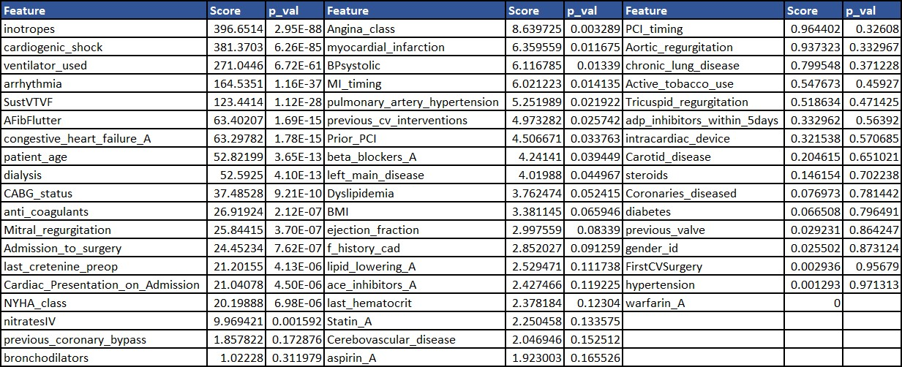
The table shows that inotropes, cardiogenic_shock, ventilator_used, arrhythmia, SustVTVF, AFibFlutter, congestive_heart_failure_A, patient_age, dialysis, CABG_status, anti_coagulants, Mitral_regurgitation, Admission_to_surgery, and last_cretenine_preop have the most effect on the target variable. Their corresponding p-values are also quite low, suggesting that these variables are quite significant.

4.2 Feature Selection
The methodology used in the article revolves around ensemble method of feature selection along with its verification via elicitation method. To ensure that the ensemble feature selection has all the relevant biomarkers for mortality prediction, a questionnaire was created and released for healthcare professionals to score the importance of pre- operative variables. The results of the questionnaire were compiled via averaging the score against each variable and assigning them a rank starting off with 1 for the most important and 55 for the least important variable. Once the master list with diagnostically relevant variables was created, it was used to rank the final ensemble feature list.
Multiple feature selection techniques: XGBoost, Random Forest, Lasso and Ridge regression, were used to make an ensemble. Each feature selection method resulted in a unique set of features with their corresponding importance. These feature vectors were then used to train an XGBoost model to get an F1 score. The intuition behind training an XGB model on each of the feature vectors (resulted via mentioned feature selection method) and later using the resultant F1 score as the weight was to assess the predictive prowess of each feature vector (Neumann, et al. 2016). The table below shows the FS method along with the resultant F1 score acquired.
Table 3: FS & F1 Score
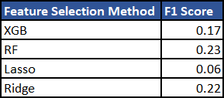
Each feature vector with their feature importance was scaled with their corresponding F1 score and later ranked. The ranking was done for each method to keep the feature importance homogeneous across mean and standard deviation. These rankings of all feature vectors were then averaged and ranked again to get an ensemble. This ensemble feature vector was then filtered with the master list (acquired via elicitation method) to ensure that the ensemble resulted in diagnostically viable features. The features of the dataset along with their final rankings are given in the table below:
Table 4: Ensemble Feature List
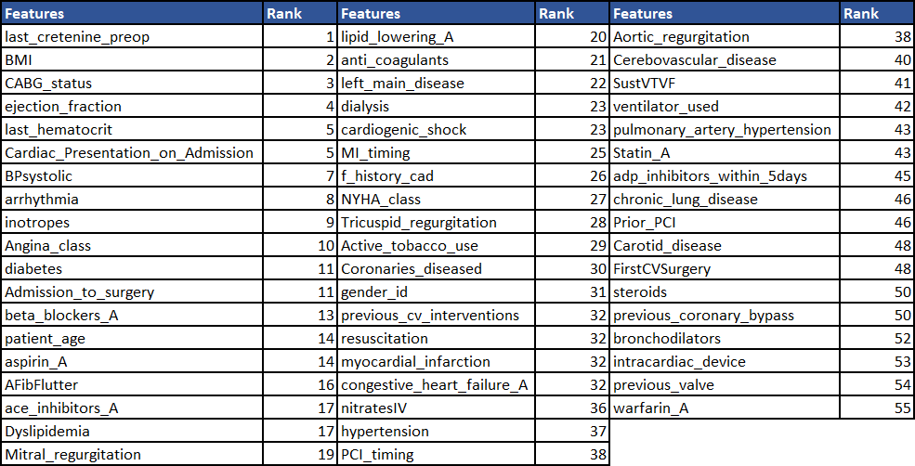
These diagnostically viable features were then used for the classification task for which Firth Logistic Regression and Bayesian Inference methods were employed. The explanation of these methods is in the subsequent sections of the article.

4.3 Models

4.3.1 Bayesian Inference Model
The Bayesian inference method employed for this study is inspired by the works of (Beck and Pauker 1983), and (Pedroza 2006) that used multiple statistical approaches, ranging from estimation via bayes theorem to more complex Markov-chain monte- Carlo simulation for medical diagnostics. MCMC methods have been proven to be more robust than traditional ML algorithms when sample size is small and highly imbalanced. They work to minimize the expected value posterior via continuous sampling which results in convergence over different parameter values. MCMC method comprises of a Markov model that defines a set of discreet states for a particular parameter. For instance, a patient can be classified as ‘Healthy’, ‘Ill’, or ‘Dead’. A patient can only reside in one of the states at a particular time defined by time $t$. After a fixed interval at time $t + 1$, the patient state can be transitioned to the other states based on transition probabilities. These transition probabilities consider only the current state to jump over to the next state. In other words, the process is memoryless. The value of the current state is enough to predict and transition to the next. This assumption is known as Markovian assumption and sets the basis for Markov process.
The other important component of MCMC algorithm is the classical method of Monte-Carlo simulation initially proposed by (Beck and Pauker 1983). The intuition behind the workings of Monte-Carlo simulation is Central Limit Theorem. It is a technique that samples from a distribution to approximate the desired parameter. It simplifies the problem of estimating the probability of parameters given a set of data points, by ignoring the effect of intractable denominator in Bayes theorem.
$$P(θ |Y) \sim P(Y|θ) ∙ P(θ)$$
When the constant of proportionality is removed it introduces a normalization term into the bayes theorem,
$$P\left(θ | Y\right)= \frac{P(Y|θ) ∙ P(θ)}{P(Y)}$$
Where $P(Y)$ or marginal of $Y$ is given by integrating the product of likelihood and prior.
$$∫ P(Y|θ) ∙ P(θ)dθ$$
In MCMC method, the process of estimating the posterior is catered by the monte- Carlo simulation which samples new values from the posterior repeatedly. Whereas the Markov-chains guides this sampling to convergence. Without Markov-chains, the process of sampling from the posterior will be completely random and become computationally intensive. MCMC method starts out with randomly selecting a state from a proposal distribution defined by the priors of the model $P_{p}$. The values that are sampled in the state are either accepted or rejected based on acceptance probability $P_{a}$ The process continuous until the estimated posterior is like the actual posterior. In other words, stationary distribution is achieved (when the states do not change when multiplied by the transition matrix).
Mathematically, the condition of stationarity approximating the posterior is:
$$P\left(S_{1}\right)∙T\left(S_{1} → S_{2}\right)= P\left(S_{2}\right)∙T(S_{2} → S_{1}) … (1)$$
The probability of transitioning to state $S_{2}$ from $S_{1}$ given the probability of state 1, is equal to transitioning to state $S_{1}$ from $S_{2}$ given the probability of $S_{2}$. If the probability flow from one state to another reaches an equilibrium, it is said to have achieved the stationary distribution which approximates the posterior of the given problem. The transition $T(S_{1} → S_{2})$ occurs when the proposal probability $P_{p}$ is accepted by the acceptance probability $P_{a}$. This means that transition probability is a function of proposal and acceptance probabilities such that,
$$T(S_{1} → S_{2}) = P_{p}(S_{1}| S_{2})∙A(S_{1} → S_{2})$$
Substituting the above into equation 1 gives,
$$P(S_{1})∙P_{p} (S_{1}| S_{2})∙A(S_{1} → S_{2}) = P(S_{2})∙P_{p} (S_{2}| S_{1})∙A(S_{2} → S_{1}) … (2)$$
The probability of being at state 𝑆1 is the probability of ‘seeing’ the target variable given the values of the parameters:
$$P(S)=P\left(Y | θ\right)= \frac{P\left(θ | Y\right) ∙ P(θ)}{P(Y)}$$
Hence the equation 2 transforms into,
$$\frac{P(Y|θ_{1}) ∙ P(θ_{1})}{P(Y)}∙P_{p} (S_{1}| S_{2})∙A(S_{1} → S_{2})= \frac{P(Y|θ_{2}) ∙ P(θ_{2})}{P(Y)}∙P_{p} (S_{2}| S_{1})∙A(S_{2} → S_{1})$$
The intractable denominator gets cancelled out which gives the following equations,
$$\frac{P(Y|θ_{2}) ∙ P(θ_{2})}{P(Y|θ_{1}) ∙ P(θ_{1})}$$
Or $R_{f}$
$$\frac{P_{p} (S_{2}| S_{1})}{P_{p} (S_{1}| S_{2})}$$
Or $R_{g}$
$$\frac{A(S_{1} → S_{2})}{A(S_{2} → S_{1})}= R_{f}∙R_{g}$$
Hence, we get the acceptance probability as,
$$A\left(S_{1} → S_{2}\right)=max⁡(1, R_{f}∙R_{g})$$
To implement Bayesian inference via MCMC method, this study uses pymc3 library of python programming language that provides a comprehensive set of tools and methods for Bayesian statistical modelling. Given the dichotomous nature of the target variable it was required that the sampling must be done from a discreet probability distribution. The target variable can be thought of as the response variable $Y_{1}, Y_{2}, … , Y_{n}$ for $n$ Bernoulli trials where probability of success $p$ is a function of training data and parameters $β$. The problem can be modelled as:
$$Z = α + β_{1} ∙ X_{1} + β_{2} ∙ X_{2} + β_{3} ∙ X_{3}+ ⋯ + β_{n} ∙ X_{n}$$
$$P=\frac{1}{1+e^{-Z}}$$
As seen from the equation above, the linear combination of training data and parameter betas, logits, are transformed into the scale between 0 and 1 via logistic function. This transformed value is the probability of success for each Bernoulli trial. The MCMC method then samples the posterior from Bernoulli likelihood function to estimate the true density of the target variable,
$$Y_{i} = Bernoulli \left(P_{i} \right), i = 1, 2, 3, ⋯ , n$$

4.3.2 Firth Logistic Regression Model
The firth logistic regression, first introduced by David Firth in 1993 is an enhancement of simple logistic regression. It helps to minimize the effect of variables that introduce complete or quasi-complete separation in the model. As these variables tend to predict the outcome perfectly (due to insufficient data and scarcity of minority class samples), it tends to add an unwanted bias into the model which increases the effect of the variable on the predictions by exploding its coefficient.
Firth logistic proposes a penalty on the maximum likelihood function of logistic regression. Usually that penalty is Jeffrey’s invariant prior (invariant in terms of transformations) that helps to reduce the effect of such variables. Traditionally, the MLE for logistic regression is given as,
$$L(Θ) = \sum{[y_{i} log(π_{i}) + (1 - y_{i}) log(1 - π_{i})]}$$
The goal of the fifth logistic is to shrink the coefficients such that they do not impose any unwanted bias on the outcomes. The penalty proposed by firth logistic regression model is the square root of the determinant of Fischer Information Matrix. This matrix tells the amount of information a random variable has about its parameter.
By adding the penalty, the MLE becomes,
$$L(Θ) = \sum{\left[y_{i} log\left(π_{i}\right)+ \left(1 - y_{i}\right)log\left(1 - π_{i}\right)\right]+0.5 log[\det{I(Θ)}]}$$

Chapter 5

Results & Discussion
The ensemble feature selection technique resulted in diagnostically viable variables which were used to train Firth Logistic Regression model along with Bayesian Inference models to predict mortality in cardiac patients.
MCMC logistic model was created in pymc3 using all variables that were deemed relevant by the ensemble feature selection method. The trace of the sampler is given below:
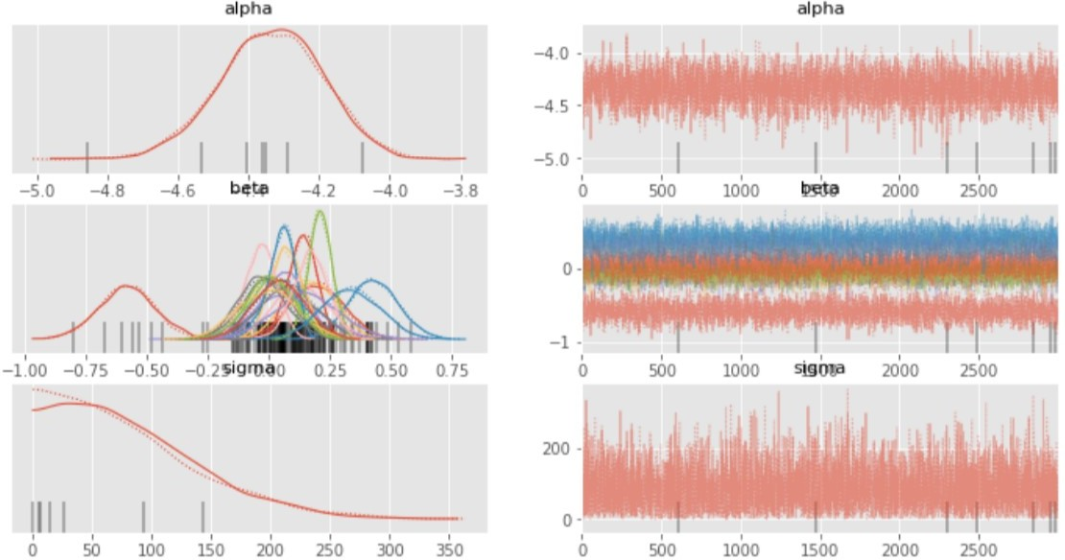
Figure 4: Trace Plot (Ensemble FS)
The trace shows satisfactory convergence with good posterior estimation with Bernoulli likelihood and normal priors. The ROC curve, along with precision and recall against different threshold values for MCMC model are given in the graphs below: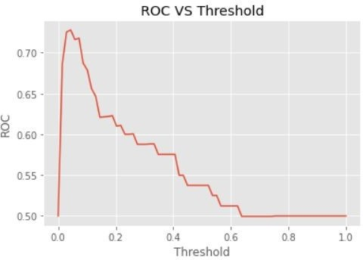
Figure 5: ROC vs Threshold (MCMC)
As seen from the graph, ROC rises steeply to the maximum of 0.81 for thresholds values between 0 and 0.17 before falling sharply to 0.5. It’s evident from the graph that lower threshold values result in better ROC than higher values. It’s partly due to the highly imbalanced nature of the dataset which introduces a small bias towards the majority class (0). The forecasts sampled from the posterior distribution gives very small prediction values (closer to zero) due to which identifying a sound boundary between the two classes becomes quite difficult.
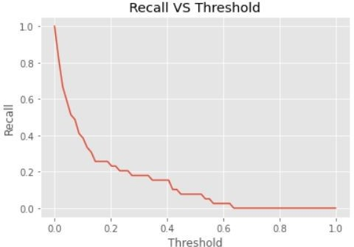
Figure 6: Recall vs Threshold (MCMC)
The recall vs threshold graph depicts a similar phenomenon. The recall is very high for lower values of the threshold but decreases exponentially when threshold is increased. Because as the threshold is increased more and more values get wrongly classified as false negatives (mortality occurs but is not predicted correctly). This happens because the predicted probabilities are closer to zero. Increasing the threshold would naturally reduce the number of patients who could be identified as at-risk patients.
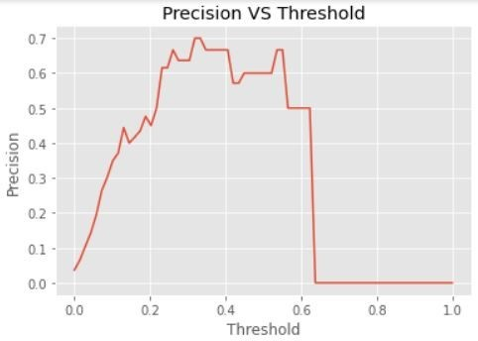
Figure 7: Precision vs Threshold (MCMC)
The precision vs threshold curve shows an almost opposite response where smaller values of threshold do not improve the precision. However, at higher values of threshold, 0.2-0.6, a significant rise in precision is visible. More true positives get identified to an extent, whereby increasing any more of the threshold results in an increase in false positives as well which decreases the precision.
It can be seen from the above results that precision and recall are inversely related for this classification problem. Increasing one would result in a decrease in another. When such a classification task is presented, it is recommended to choose either precision or recall according to the domain and use-case. Once correct metric is identified, the efforts can be directed towards increasing it.
The results above were acquired when features from ensemble feature selection methods were used. As a comparison, the graph below shows a standard, baseline MCMC model without any ensemble FS:
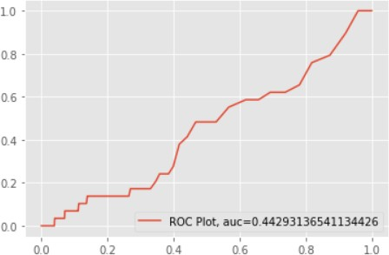
Figure 8: ROC (Baseline)
As seen from the graph above, the model was not able to correctly sample from the posterior and resulted in divergent chains as seen from the trace plot below:
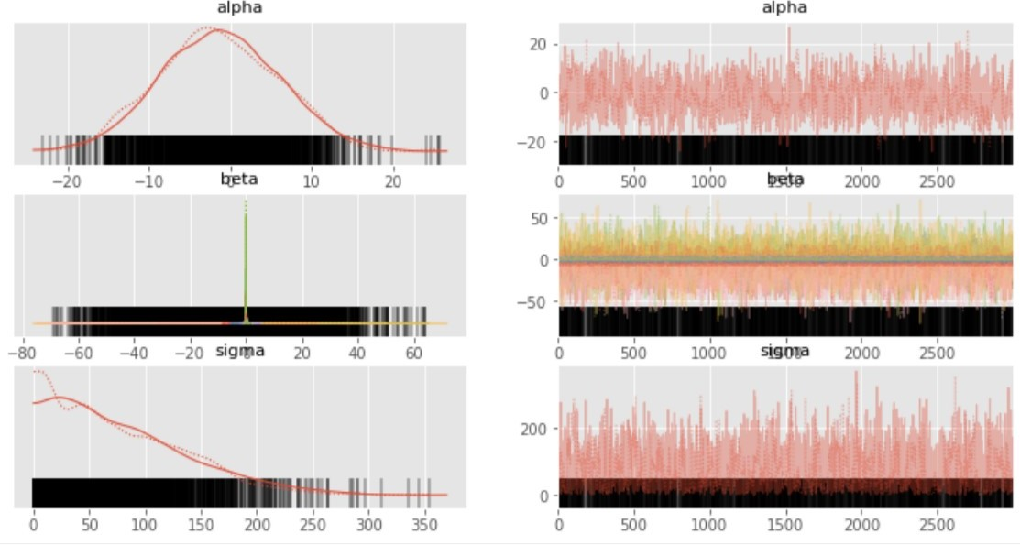
Figure 9: Trace Plot (Baseline)
As seen from the above comparative analysis, it is evident that using an elicitation- backed, feature selection method resulted in much better classification metrics. It is because of the inclusion of more indicative features in the model building which were not present in baseline model. The ROC, precision, and recall against different values of threshold for Firth Logistic Regression is given below:
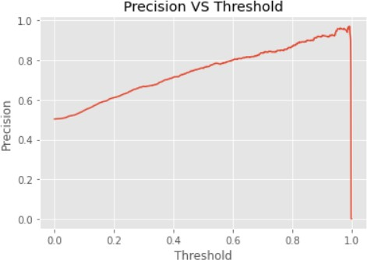
Figure 10: Precision vs Threshold (Firth)
As seen from the graph above, the precision increases as the threshold increases. Because as the threshold increases, the model can detect more true positives.
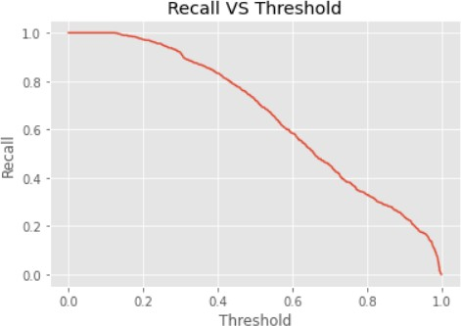
Figure 11: Recall vs Threshold (Firth)
The graph of recall vs threshold shows similar inverse behavior to precision- threshold curve. As the threshold increases, the recall decreases. Because at higher thresholds the model cannot classify true positives and ends up classifying more false negatives.
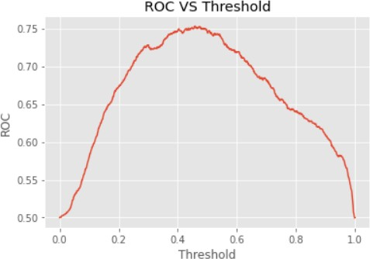
Figure 12: ROC vs Threshold (Firth)
The ROC curve shows that the highest value if ROC is 0.83 when the threshold is between 0.4 - 0.6. The metric graphs of firth have shown considerable improvement over Bayesian inference method. Largely because of imbalanced dataset having reduced sample size and quasi-complete separation. The coefficients estimated via Firth logistic are given in the table below:
Table 5: Coefficients
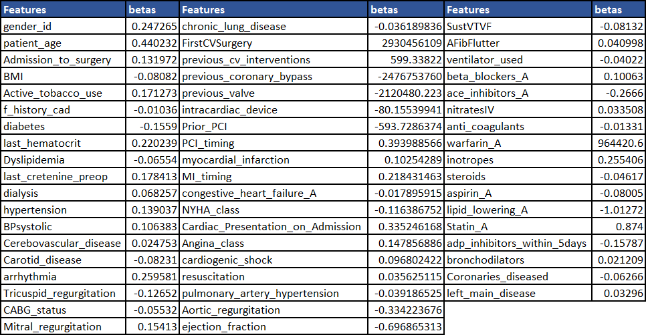

Chapter 6

Conclusion
This study tries to explore the different algorithms that could model the mortality of cardiac patients based on pre-operative variables, along with an elicitation-backed ensemble feature selection method that could potentially incorporate a professional bias into the process of feature selection which is often ignored. The study investigates the predictive prowess of different machine learning algorithms which did not perform quite as well largely due to the nature of the dataset. As this data is not ‘solved’ and is compiled in real-time by a team of professionals makes it even more challenging to come up with a sound model that could result in great accuracies over classification metrics. The use of ML algorithms, with or without sampling did not improve the results any further. To overcome this roadblock, the study investigates Bayesian inference methods. MCMC models have been said to perform well on real-life data. They have found their application in financial analytics, environmental sciences, and healthcare. Using the principle of guided simulation, these methods generalize better than ML algorithms when the dataset is imbalanced. Sampling directly from the posterior with a likelihood and a prior makes the problem quite easy but computationally extensive. Building upon the process of sampling, Firth logistic regression, an enhancement of simple logistic regression helps to reduce the bias of some unwanted features. Quasi-complete or complete separation has plagued the generations of researchers with the problem of exploding coefficients. Whenever the dataset encounters quasi-complete separation, there is a variable that can fully predict the outcome. But that is not the case. It happens due to the scarcity of data samples and the unequal distribution of the class labels, which end up making a variable, seemingly unimportant, a complete indicative of the target variable. Then maximum likelihood function of logistic regression tries to maximize the likelihood of only that variable and hence increases its effect on the predictions which results in wrong and biased outcomes. The study makes use of firth logistic regression along with ensemble feature selection to report good results over ML algorithms. The ROC via ML algorithm was limited to 0.70-0.75 which increased to 0.83 in Firth logistic and 0.81 in MCMC method. Similarly, precision and recall which were 0.34 and 0.70 for ML algorithms were increased to 0.7 and 0.8 for Firth logistic and 0.6 and 0.7 for MCMC method. The results can be further improved by assuming the problem to be of outlier/anomaly detection instead of a classification one. As the number of minority class is less than 2% of the majority, it makes sense to see the problem in light of anomaly detection. PyOD, an opensource python library provides a plethora of anomaly detection algorithms ranging from simple tree-based methods to variational encoders. Similarly, with MCMC methods, one can model the problem in such a way that it can be simulated as outlier detection. Using gaussian mixture models to learn the joint probability and later using the distance between the learned posterior to a new data point can essentially help to place that observation as an inlier or outlier.

References
Ahmad, Fahad Shabbir, Liaqat Ali, Raza Ul-Mustafa, Hasan Ali Khattak, Tahir Hameed, Iram Wajahat, Seifedine Kadry, and Syed Ahmad Chan Bukhari. 2021. "A hybrid machine learning framework to predict mortality in paralytic ileus patients using electronic health records (EHRs)." Journal of Ambient Intelligence and Humanized Computing 12 (3): 3283-3293. doi:10.1007/s12652-020-02456-3.
Ali, L., and S. A. C. Bukhari. 2021. "An Approach Based on Mutually Informed Neural Networks to Optimize the Generalization Capabilities of Decision Support Systems Developed for Heart Failure Prediction." IRBM 42 (5): 345-352. doi:10.1016/j.irbm.2020.04.003.
Ariyaratne, Thathya V., Baki Billah, Cheng-Hon Yap, Diem Dinh, Julian A. Smith, Gilbert C. Shardey, and Christopher M. Reid. 2011. "An Australian risk prediction model for determining early mortality following aortic valve replacement." European journal of cardio-thoracic surgery 39 (6): 815-821. https://academic.oup.com/ejcts/article/39/6/815/375457.
Beck, J. Robert, and Stephen G. Pauker. 1983. "The Markov Process in Medical Prognosis." Medical Decision Making 3 (4): 419-458. doi:10.1177/0272989X8300300403.
Berg, K. S., R. Stenseth, H. Pleym, A. Wahba, and V. Videm. 2011. "Mortality risk prediction in cardiac surgery: comparing a novel model with the EuroSCORE." Acta Anaesthesiologica Scandinavica 55 (3): 313-321.
Bhatti, Farah, Antony D. Grayson, Geir Grotte, Brian M. Fabri, John Au, Mark T. Jones, and Ben Bridgewater. 2006. "The logistic EuroSCORE in cardiac surgery: how well does it predict operative risk?" Heart 92 (12). doi:https://doi.org/10.1136/hrt.2005.083204.
Celi, Leo Anthony, Sean Galvin, Guido Davidzon, Joon Lee, Daniel Scott, and Roger Mark. 2012. "A Database-driven Decision Support System: Customized Mortality Prediction." Journal of Personalized Medicine 2 (4): 138-148. doi:10.3390/jpm2040138.
Chang Junior, João, Fábio Binuesa, Luiz Fernando Caneo, Aida Luiza Ribeiro Turquetto, Elisandra Cristina Trevisan Calvo Arita, Aline Cristina Barbosa, Alfredo Manoel da Silva Fernandes, Evelinda Marramon Trindade, and Fábio Biscegli Jatene. 2020. "Improving preoperative risk-of-death prediction in surgery congenital heart defects using artificial intelligence model: A pilot study." PLOS ONE.
Daniels, Justin, and Brigid C. Flynn. 2020. "Novel Tool to Predict 1-Year Mortality in Cardiac Surgery: Applying Both Preoperative and Postoperative Data." Journal of Cardiothoracic and Vascular Anesthesia (Elsevier) 34 (10): 2638-2640. doi:10.1053/j.jvca.2020.06.065.
de Kruyk, A R, J H van der Meulen, L A van Herwerden, J A Bekkers, E W Steyerberg, R Dekker, and J D Habbema. 1998. "Use of Markov series and Monte Carlo simulation in predicting replacement valve performances." The Journal of heart valve disease 4-12.
de la Varga-Martínez, Olga, Estefanía Gómez-Pesquera, María Fe Muñoz-Moreno, José Miguel Marcos-Vidal, Amparo López-Gómez, Frederic Rodenas-Gómez, Fernando Ramasco, Felisa Álvarez-Refojo, Eduardo Tamayo, and Esther Gómez-Sánchez. 2021. "Development and validation of a delirium risk prediction preoperative model for cardiac surgery patients (DELIPRECAS): An observational multicentre study." Journal of Clinical Anesthesia 110158-69.
Ding, Chris, and Hanchuan Peng. 2005. "MINIMUM REDUNDANCY FEATURE SELECTION FROM MICROARRAY GENE EXPRESSION DATA." Journal of Bioinformatics and Computational Biology 185-205.
Engerstrom, Lars, Wolfgang Freter, Johan Sellgren, Folke Sjoberg, Mats Fredrikson, and Sten M. Walther. 2020. "Mortality Prediction After Cardiac Surgery: Higgins’ Intensive Care Unit Admission Score Revisited." The Annals of Thoracic Surgery 1589-1594.
Fernandes, Marta Priscila Bento, Miguel Armengol de la Hoz, Valluvan Rangasamy, and Balachundhar Subramaniam. 2021. "Machine Learning Models with Preoperative Risk Factors and Intraoperative Hypotension Parameters Predict Mortality After Cardiac Surgery." Journal of Cardiothoracic and Vascular Anesthesia 857-865.
Firth, David. 1993. "Bias Reduction of Maximum Likelihood Estimates." Biometrika 80 (1): 27. doi:10.2307/2336755.
Granton, Jeff, and Davy Cheng. 2008. "Risk Stratification Models for Cardiac Surgery." Seminars in Cardiothoracic and Vascular Anesthesia 12 (3): 167-174. doi:10.1177/1089253208323681.
Guillet, Laura, PierreH Moury, Damien Bedague, Michel Durand, Cécile Martin, JeanF Payen, Olivier Chavanon, and Pierre Albaladejo. 2020. "Comparison of the additive, logistic european system for cardiac operative risk (EuroSCORE) with the EuroSCORE 2 to predict mortality in high-risk cardiac surgery." Annals of Cardiac Anaesthesia 23 (3): 277. doi:10.4103/aca.ACA_209_18.
Head, S. J., R. L. J. Osnabrugge, N. J. Howell, N. Freemantle, B. Bridgewater, D. Pagano, and A. P. Kappetein. 2013. "A systematic review of risk prediction in adult cardiac surgery: considerations for future model development." European Journal of Cardio-Thoracic Surgery 43 (5): e121-e129. doi:10.1093/ejcts/ezt044.
Heinze, Georg, and Michael Schemper. 2002. "A solution to the problem of separation in logistic regression." Statistics in Medicine 21 (16): 2409-2419. doi:10.1002/sim.1047.
Higgins, Thomas L. 1998. "Quantifying risk and assessing outcome in cardiac surgery." Journal of Cardiothoracic and Vascular Anesthesia 12 (3): 330-340. doi:10.1016/S1053-0770(98)90018-0.
Ivanchuk, M. A., and P. R. Ivanchuk. 2018. "USING THE MONTE CARLO MARKOV CHAIN TO PREDICT THE PREVALENCE OF CORONARY HEART DISEASE IN UKRAINE." Medical Informatics and Engineering (4). doi:10.11603/mie.1996-1960.2017.4.8466.
Jongbo, Olayinka Ayodele, Toluwase Ayobami Olowookere, and Adebayo Olusola Adetunmbi. 2020. "Performance Evaluation of an Ensemble Method for Diagnosis of Chronic Kidney Disease with Feature Selection Technique." IEEE. 959-965. doi:10.1109/DASA51403.2020.9317190.
Knorr-Held, L. 2001. "Projections of lung cancer mortality in West Germany: a case study in Bayesian prediction." Biostatistics 109-129.
Lamarche, Y., D. Sirounis, J. G. Abel, M. Gao, L. Ding, and S. V. Lichtenstein. 2011. "New intensive care risk score to predict mortality after cardiac surgery." Canadian Journal of Cardiology (Elsevier) 27 (5): S196. doi:10.1016/j.cjca.2011.07.315.
Lesyuk, Wladimir, Christine Kriza, and Peter Kolominsky-Rabas. 2018. "Cost-of-illness studies in heart failure: a systematic review 2004–2016." BMC Cardiovascular Disorders 18 (1): 74. doi:10.1186/s12872-018-0815-3.
Neumann, Ursula, Mona Riemenschneider, Jan-Peter Sowa, Theodor Baars, Julia Kälsch, Ali Canbay, and Dominik Heider. 2016. "Compensation of feature selection biases accompanied with improved predictive performance for binary classification by using a novel ensemble feature selection approach." BioData Mining 9 (1): 36. doi:10.1186/s13040-016-0114-4.
Nilsson, Johan, Mattias Ohlsson, Lars Thulin, Peter Höglund, Samer A. M. Nashef, and Johan Brandt. 2006. "Risk factor identification and mortality prediction in cardiac surgery using artificial neural networks." The Journal of Thoracic and Cardiovascular Surgery 132 (1): 12-19.e1. doi:10.1016/j.jtcvs.2005.12.055.
Ong, Chin Siang, Erik Reinertsen, Haoqi Sun, Philicia Moonsamy, Navyatha Mohan, Masaki Funamoto, Tsuyoshi Kaneko, et al. 2023. "Prediction of operative mortality for patients undergoing cardiac surgical procedures without established risk scores." The Journal of Thoracic and Cardiovascular Surgery 165 (4): 1449-1459.e15. doi:10.1016/j.jtcvs.2021.09.010.
Pedroza, C. 2006. "A Bayesian forecasting model: predicting U.S. male mortality." Biostatistics 7 (4): 530-550. doi:10.1093/biostatistics/kxj024.
Prins, Carla, I. De Villiers Jonker, Lizelle Botes, and Francis E. Smit. 2012. "Cardiac surgery risk-stratification models." Cardiovascular Journal of Africa 23 (3): 160-164. doi:10.5830/CVJA-2011-047.
Puhr, Rainer, Georg Heinze, Mariana Nold, Lara Lusa, and Angelika Geroldinger. 2017. "Firth's logistic regression with rare events: accurate effect estimates and predictions?" Statistics in Medicine 36 (14): 2302-2317. doi:10.1002/sim.7273.
Rahim, Aqsa, Yawar Rasheed, Farooque Azam, Muhammad Waseem Anwar, Muhammad Abdul Rahim, and Abdul Wahab Muzaffar. 2021. "An Integrated Machine Learning Framework for Effective Prediction of Cardiovascular Diseases." IEEE Access 9: 106575-106588. doi:10.1109/ACCESS.2021.3098688.
Rahimi, Kazem, Derrick Bennett, Nathalie Conrad, Timothy M. Williams, Joyee Basu, Jeremy Dwight, Mark Woodward, Anushka Patel, John McMurray, and Stephen MacMahon. 2014. "Risk Prediction in Patients With Heart Failure: A Systematic Review and Analysis." JACC: Heart Failure 2 (5): 440-446. doi:https://doi.org/10.1016/j.jchf.2014.04.008.
Reid, Christopher, Baki Billah, Diem Dinh, Julian Smith, Peter Skillington, Michael Yii, Seven Seevanayagam, Morteza Mohajeri, and Gil Shardey. 2009. "An Australian risk prediction model for 30-day mortality after isolated coronary artery bypass: The AusSCORE." The Journal of Thoracic and Cardiovascular Surgery 138 (4): 904-910. doi:10.1016/j.jtcvs.2009.03.020.
Rodgers, Jennifer L., Jarrod Jones, Samuel I. Bolleddu, Sahit Vanthenapalli, Lydia E. Rodgers, Kinjal Shah, Krishna Karia, and Siva K. Panguluri. 2019. "Cardiovascular Risks Associated with Gender and Aging." Journal of Cardiovascular Development and Disease 6 (2): 19. doi:10.3390/jcdd6020019.
Savarese, Gianluigi, and Lars H. Lund. 2017. "Global Public Health Burden of Heart Failure." Cardiac Failure Review 03 (01): 7. doi:10.15420/cfr.2016:25:2.
Shahian, David M., Eugene H. Blackstone, Fred H. Edwards, Frederick L. Grover, Gary L. Grunkemeier, David C. Naftel, Samer A. M. Nashef, William C. Nugent, and Eric D. Peterson. 2004. "Cardiac Surgery Risk Models: A Position Article." The Annals of Thoracic Surgery (Elsevier) 78 (5): 1868-1877. doi:10.1016/j.athoracsur.2004.05.054.
Shickel, Benjamin, Patrick James Tighe, Azra Bihorac, and Parisa Rashidi. 2018. "Deep EHR: A Survey of Recent Advances in Deep Learning Techniques for Electronic Health Record (EHR) Analysis." IEEE Journal of Biomedical and Health Informatics 22 (5): 1589-1604. doi:10.1109/JBHI.2017.2767063.
Steinmeyer, Christian, and Lena Wiese. 2020. "Sampling methods and feature selection for mortality prediction with neural networks." Journal of Biomedical Informatics 111: 103580. doi:10.1016/j.jbi.2020.103580.
Stoica, S. 2002. "Preoperative risk prediction and intraoperative events in cardiac surgery." European Journal of Cardio-Thoracic Surgery 21 (1): 41-46. doi:10.1016/S1010-7940(01)01077-6.
Sullivan, Patrick G., Joshua D. Wallach, and John P. A. Ioannidis. 2016. "Meta-Analysis Comparing Established Risk Prediction Models (EuroSCORE II, STS Score, and ACEF Score) for Perioperative Mortality During Cardiac Surgery." The American Journal of Cardiology 118 (10): 1574-1582. doi:10.1016/j.amjcard.2016.08.024.
Thomson, Rebekah, Nick Fletcher, Oswaldo Valencia, and Vivek Sharma. 2018. "Readmission to the Intensive Care Unit Following Cardiac Surgery: A Derived and Validated Risk Prediction Model in 4,869 Patients." Journal of Cardiothoracic and Vascular Anesthesia 32 (6): 2685-2691. doi:10.1053/j.jvca.2018.04.033.
Turnan, Kenneth J., Robert J. McCarthy, Robert J. March, Hassan Najafi, and Anthony D. Ivankovich. 1992. "Morbidity and Duration of ICU Stay after Cardiac Surgery." Chest 102 (1): 36-44. doi:10.1378/chest.102.1.36.
Vincent Paul, Sofia Mary, Sathiyabhama Balasubramaniam, Parthasarathy Panchatcharam, Priyan Malarvizhi Kumar, and Azath Mubarakali. 2022. "Intelligent Framework for Prediction of Heart Disease using Deep Learning." Arabian Journal for Science and Engineering 2159-2169.
Wang, Xuefeng. 2014. "Firth logistic regression for rare variant association tests." Frontiers in Genetics 5. doi:10.3389/fgene.2014.00187.
Widyastuti, Yunita, Roar Stenseth, Kristin S. Berg, Hilde Pleym, Alexander Wahba, and Vibeke Videm. 2012. "Preoperative and intraoperative prediction of risk of cardiac dysfunction following open heart surgery." European Journal of Anaesthesiology 29 (3): 143-151. doi:10.1097/EJA.0b013e32834de368.
Zeng, Xian, Jiye An, Ru Lin, Cong Dong, Aiyu Zheng, Jianhua Li, Huilong Duan, Qiang Shu, and Haomin Li. 2019. "Prediction of complications after paediatric cardiac surgery." European Journal of Cardio-Thoracic Surgery. doi:10.1093/ejcts/ezz198.
Zhao, Zhenyu, Radhika Anand, and Mallory Wang. 2019. "Maximum Relevance and Minimum Redundancy Feature Selection Methods for a Marketing Machine Learning Platform." IEEE. 442-452. doi:10.1109/DSAA.2019.00059.

